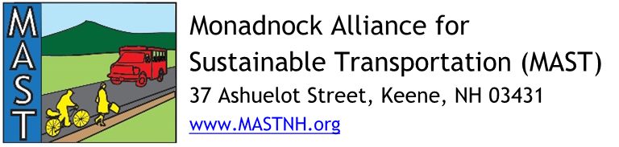
Monadnock Region Complete Streets Implementation Grant, 2021

Request for Technical Assistance to Develop a Complete Streets Policy

OVERVIEW
Municipalities that have not adopted a complete streets policy may apply for technical assistance to develop local complete streets policies including design guidelines. MAST is targeting $10,000 to $40,000 in awards in this category. This grant opportunity is intended to support municipalities seeking to develop complete streets policies for all or parts of its road network. Technical assistance is offered by SWRPC. Technical assistance from other qualified organizations or businesses will be considered on a case by case basis.
WHAT ARE COMPLETE STREETS?
Complete Streets are designed and operated to prioritize safety, comfort and access to destinations for all people who use the street, especially people whose needs have not been met through a traditional transportation approach, including youth, older adults, people living with disabilities, and people who cannot afford or do not have access to a car. There is no singular design prescription for Complete Streets. Each one is unique and responds to its community context. A complete street may include sidewalks, bike lanes (or wide paved shoulders), frequent and safe crossing opportunities, median islands, accessible pedestrian signals, curb extensions, narrower travel lanes, roundabouts, and more. A complete street in a rural area will look quite different from a complete street in a highly urban area, but both are designed to balance safety and convenience for everyone using the road. Several towns in Southwest New Hampshire have complete streets policies including Harrisville, Hinsdale, Jaffrey, Keene, Peterborough, Swanzey, Troy, Walpole, and Winchester.
MINIMUM REQUIREMENTS

- Applicants must be a municipality located in the Monadnock Region of New Hampshire. The Monadnock Region includes communities of the Southwest Region Planning Commission planning district as delineated by the New Hampshire Office of Strategic Initiatives.
- Applicants must include a letter of support from the governing board (Select Board) expressing 1) support for the request for technical assistance, 2) the reasoning and justification for the municipality’s request for policy development technical assistance, and 3) a commitment to complete the project by December 31, 2022 (see Attachment A for template letter of support).
- Applicants must also submit a quote and scope of services documenting the policy development technical assistance proposal. Contact SWRPC by July 31, 2021 using the contact information below to notify SWRPC of your intent to apply for this funding and to begin discussing desired elements of the scope of services.

SUBMISSION INSTRUCTIONS
The requested materials must be received by September 24, 2021 at 5:00 p.m. in order to be considered.

Applications may be mailed, e-mailed, or hand-delivered to:

Monadnock Alliance for Sustainable Transportation
c/o Southwest Region Planning Commission
37 Ashuelot Street
Keene, NH 03431
hunderwood@swrpc.org
PROJECT SELECTION PROCESS
The MAST Steering Committee has appointed a Subcommittee to review, score and rank policy development technical assistance requests and make funding award recommendations to the MAST Steering Committee. As part of its review, the MAST Complete Streets Subcommittee may seek clarifying information from applicants in order to fully understand and rank proposals. The MAST Steering Committee will consider the recommendations of the Complete Streets Subcommittee and present a final recommendation to the Southwest Region Planning Commission Board of Directors. The target for decisions of grant award(s) is late 2021. For more information about this funding opportunity, please see http://www.mastnh.org/2021-complete-streets-grant or contact Henry Underwood of SWRPC staff at hunderwood@swrpc.org or (603) 357-0557.

The target budget is for proposals applying for assistance through the Non-Infrastructure Application as well as the Complete Streets Policy Development Program.

